Gloves Policy Lesson

- Policy
  - All persons who come into contact with processing equipment, food contact surfaces, utensils, in-processing materials, raw materials, packaging materials and finished products are required to wear clean gloves at all times.
  - Gloves are disposed into trash can when they are worn, torn, and/or soiled.
  - Gloves are disposed into trash can after
    - Break time
    - Lunch time
    - Restroom visit
    - Sneezing, Coughing or Touching hair or face.
    - Handling or touching dirty sources.
  - New gloves are worn from:
    - Start to work in the production line.
    - After
      - Break time
      - Lunch Time
      - Sneezing, Coughing or Touching hair or face.
      - Handling or touching dirty sources.

- Procedures
  - Definition
    - The definitions and interpretations of terms in this procedure are applicable to such terms when used in this part. The following definitions shall also apply:
    - Maintaining gloves used in food handling, in an intact, clean, and sanitary condition. (21 CFR 117.10 (b) (5))

  - Equipment / Materials
    - Gloves
      - Latex – Powder Free
        - May cause allergic reaction for personnel allergic to latex.
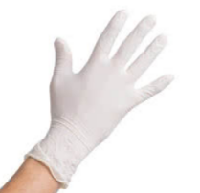

      - Neoprene – Latex Free (if allergic to latex)
        - For high risk situations
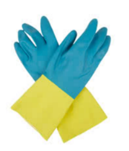

      - Nitrile – Powder Free
        - Chemically resistant
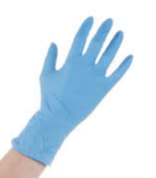

      - Poly
        - Not ideal for high risk and hazardous materials
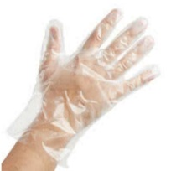

      - Vinyl
        - Not ideal for high risk and hazardous materials
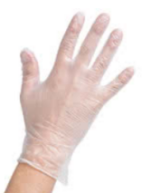

  - Requirements
    - Glove / Dispenser
      - Model / make / supplier
      - Sizes
      - Resistance Type
    - Glove Caution Sign
      - Reference Supplier: www.mysafetysign.com
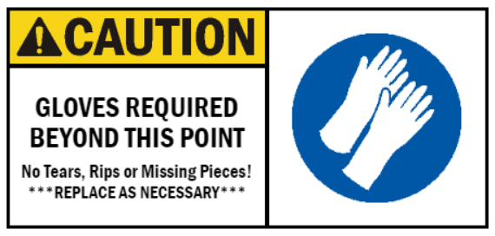

  - Installations
    - Glove / Dispensers
      - Must be secured to the wall (utilize screws, nuts and bolts, if applicable)
      - Caulk around the edges that are flushed against the wall structure to make a water seal-tight fixture.
        - Caulking Materials, including silicone, silastic, or stainless-steel epoxy types: May be used to seal pockets or crevices on exterior, non-product contact surfaces. Reference – USDA Guidelines
    - Glove Caution Sign
      - Place directly at 5 to 6-foot height from floor for easy-to-read instruction for personnel.
  - Glove Donning
    - Open glove packaging
      - Peel open glove box dispenser
      - Unfold glove
      - Pinch the hand entry interior side of the glove if possible. (Photo is for reference use only)
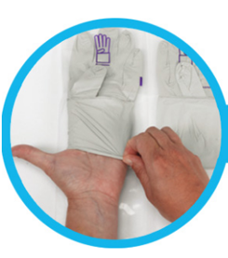

      - Apply first glove to hand by sliding hand into glove. (Photo is for reference use only)
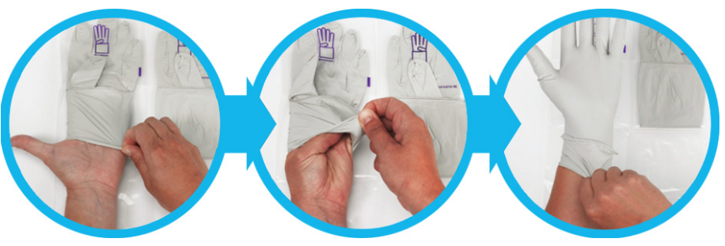

      - Apply second glove to other hand. (Photo is for reference use only)
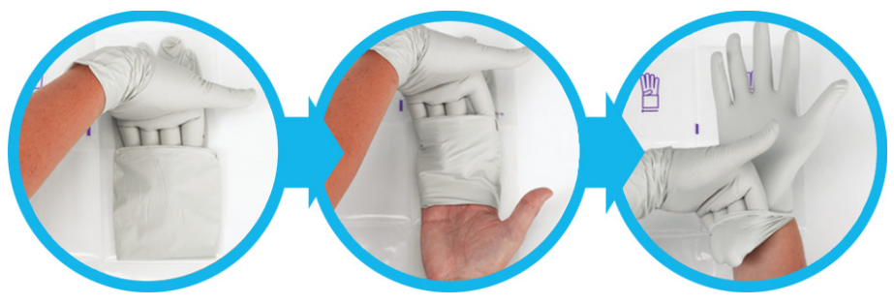

      - Complete donning the gloves by pulling up the cuff of the first glove with the fingers of the second hand - Isopropyl Alcohol (IPA) may be used to clean the surface of the gloved hands if required. (Photo is for reference use only)
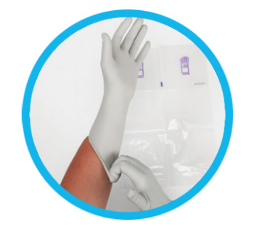

      - If double donning is desired, repeat steps 2.5.1.3 to 2.5.1.6 with a second set of gloves - this time using a half inch size larger glove if necessary. Example: Medium to Large size.

  - Frequency
    - Daily
      - PCQI / Quality
        - Inspect glove dispenser station security, integrity and functionality.
        - Caulking degradation
        - Consumable item levels
    - Monthly
      - PCQI / Quality / Maintenance / Facility Personnel
        - Verify glove dispenser station security, integrity and functionality.
        - Document all discrepancies and corrective actions on Corrective Action & Preventive Action Report Form
        - Repair or replace dispenser as necessary.

- Responsibility
  - All Personnel
    - Who encounter the plant floor or involve with the raw ingredients, exposed products, packaging materials and finished products must wear gloves.
  - Housekeeping / Designated Department Personnel
    - Ensure gloves are refilled, replaced, and available along with the approved consumables (Soap, Disposable Paper Towels, Sanitizer, Disinfecting Agents, Trash Bin Liners) frequently as necessary.
    - Document the procedure by affixing initial, date, and time on Handwash Station Inspection Log
  - Preventative Control Qualified Individual (PCQI)
    - Inspect gloves are available on all PPE locations.
    - Ensure gloves utilized by personnel are intact (no tears, rips or missing pieces)
    - Personnel proper glove donning training (GLOVES DONNING TRAINING)
  - Supervisors or department heads and team leaders are responsible to ensure (inspect) and verifying that consumables (Gloves, Soap, Disposable Paper Towels, Sanitizer, Disinfecting Agents, Trash Bin Liners) are refilled and replaced frequently.
    - Document the procedure by affixing the initial, date, and time on Handwash Station Inspection Log
  - Quality Personnel.
    - Validate those consumables (Gloves, Soap, Disposable Paper Towels, sanitizers, Disinfecting Agents, Trash Bin Liners) are refilled and replaced frequently.
    - Monitor and document non-conformance observation, also known as discrepancy, using Corrective Action & Preventive Action Report
    - Document the procedure by affixing the initial, date, and time on Handwash Station Inspection Log
  - Quality / Compliance Department.
    - Document all records.
    - Document control and archive.

- Corrective Action
  - Train all personnel on glove policy and donning procedures.
  - Non-compliance will require re-training or dismissal from job duties or termination of employment.

- Preventative Action
  - GMP retraining and familiarization course/lesson.

- History
Revision No.: | Revision Date: | Description of Change: | Originator / Author Name: | Title / Department:
0 | 20230110 | Original | Arnel Ryan | PCQI / Compliance

Requirements:
- The trainee (employee/visitor) has read or received a verbal translation of all or part of the policy, procedure, method, and/or SOP for which they are being trained.
- The trainee has observed a demonstration of the task they are to perform or the procedure for which they are being trained as required.
- The trainee has demonstrated the ability to perform the task with acceptable proficiency and minimal supervision.

